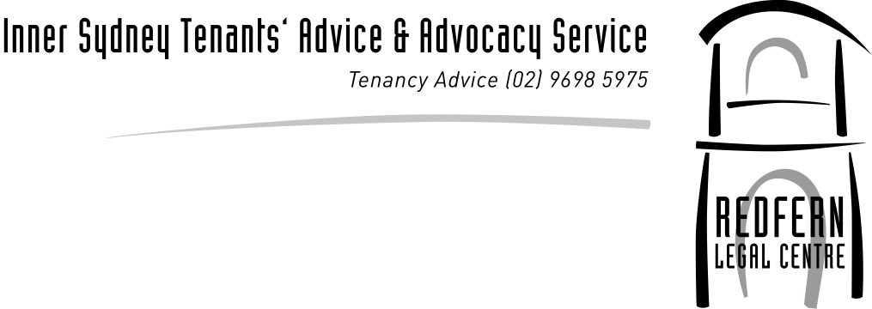

Media Release 4th August 2011

New Legal Kit Shows Boarders, Lodgers and Share Houses Left Out in the Cold
As part of National Homeless Persons Week, Redfern Legal Centre launched their new Boarders Legal Kit. The Lord Mayor Clover Moore MP, who funded the kit through her Lord Mayor Salary Trust, launched the kit.

Jacqui Swinburne, Tenants Service Coordinator at Redfern Legal Centre said that, ‘unlike most States in Australia, there is no specific set of legislation for boarders. If someone has paid their rent but is being evicted with no notice, or they can’t get back their things or their bond, they need to try and rely on other types of consumer legislation and the common law. This makes their legal matters extremely complex and often unattainable due to the Court costs involved.’

‘We have written a kit to give an overview of the various laws that can be used but really it shows that the current laws are woefully inadequate for boarders and lodgers. While they are often paying the same or more for a room than a tenant, their rights are extremely limited. An example of this is the lack of legal rights to get repairs done, which in some cases needs to be an equitable claim for specific performance at the Supreme Court of NSW.’

A boarding house resident, Sarah Bell, stated, ‘I have lived in boarding houses over the last 6 to 7 years and had a lot of problems. I’ve seen safety issues like fire alarms not being turned on. I’ve experienced electric shocks coming through the switches in bathrooms because the wiring is faulty. I’ve seen holes in kitchen walls and rats running in and out and toilets overflowing without being fixed for days. Rooms are tiny and have no windows and people who come out of prison say they are smaller than their cells in prison. I know of some boarding houses that have given an hours notice to get out or where they regularly take bond and do not return it to the residents when they leave. There is often no security. I answered the door one day and I was thrown from the front door to the front gate and ended up with two fractured ribs,’ said Ms Bell.

Ms Swinburne said, ‘with the introduction of the Residential Tenancies Act 2010 many residents in share housing are now excluded from tenancy laws. Unless they are named on the lease or have a written residential tenancy agreement with the head tenant, the new tenancy laws do not cover them. This also allows for easy exploitation of young people such as the specific targeting of international students. Having occupants in share housing excluded by the tenancy laws has greatly increased the number of boarders and lodgers in NSW. This further highlights the well overdue need for legislation to be enacted to cover Boarders and Lodgers and we call on the new government of NSW to support Clover Moore’s Private Members Bill.’

The kit can be downloaded at rlc.org.au

Jacqui Swinburne Jo Shulman
Coordinator, Inner Sydney Tenants' Advice Service (RLC) CEO Redfern Legal Centre
Jacqui@rlc.org.au Joanna@rlc.org.au
9698 7277 9698 7277

